Lecture 3 ECE 2312

* Goals:
  + Define ohms law
  + Voltage
  + Current and power
* Ohms Law
  + Allows us to understand how to transport power efficiently…
  + Allows us to design electrical circuits
* Resistor
  + Passive element characterized by an algebraic relation between the voltage across its terminals and the current through it
  + V(t) = F(i(t)) General model for resistor
  + V(t) = R\*i(t) -> V=IR
    - R is constant and is resistance and is measured in OHMS.
    - OHM is a derived unit of volt/amp
  + Remember conductance is just the reciprocal of reistance, = 1/r
    - So could be i=Gv
  + Electric power stuff
    - 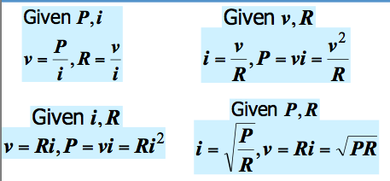
* KCL/KVL
  + Charge can neither be created or destroyed in a circuit
  + Nodes: points where 2 ore more elements are joined together.
  + Loop: a closed path that never goes twice over a node.
  + KCL
    - Current into the node must = current going out of the node.
    - Currents going in are positive
    - Currents going out are negative
    - Or you can even flip the above, as long as you stay consistent throughout your problem.
  + KVL
    - Conservation of energy principle
    - A positive charge gains energy as it moves to a point with higher voltage and releases energy if it moves to a point with lower voltage.
      * Kind of like a me riding up a hill.
      * Or a spring being compressed.
    - Whatever voltage gain we have at some point has to be balanced out by a loss somewhere else.
    - So sum of all of the voltages must = 0 in a well defined loop.